Roadwatch: A Geospatial Decision-Support Dashboard for Municipal Road-Defect Monitoring and Maintenance Triage
[Author 1 Full Name]  Student Author  School of Computer Science and Engineering  Vellore Institute of Technology, Chennai, India  [author1 email] | [Author 2 Full Name]  Student Author  School of Computer Science and Engineering  Vellore Institute of Technology, Chennai, India  [author2 email] | [Author 3 Full Name]  Student Author  School of Computer Science and Engineering  Vellore Institute of Technology, Chennai, India  [author3 email]
[Faculty Full Name]
Faculty Guide / Corresponding Author
[Faculty Department / School]
Vellore Institute of Technology, Chennai, India
Corresponding author: [faculty institutional email]

Abstract—Urban road defects require timely observation, geographic context, and coordinated maintenance decisions. A detected pothole becomes operationally useful only when its location, severity, evidence, and review status can be inspected and acted upon. This paper presents Roadwatch, a browser-based geospatial decision-support dashboard designed to organize road-defect records for municipal triage in Chennai. Implemented with HTML, CSS, and JavaScript, the system uses Leaflet for map interaction and CARTO basemap tiles with OpenStreetMap attribution. A shared client-side state coordinates severity-coded markers, key performance indicators, severity and time-trend summaries, a searchable and sortable register, a detail drawer, and record-level workflow actions. The paper describes the architecture, a structured defect-event schema, and a proposed data-science layer for coordinate validation, duplicate-event grouping, road-segment aggregation, spatial hotspot analysis, and interpretable prioritization. Functional checks cover map and table synchronization, search, filters, sorting, summaries, status transitions, theme behavior, and responsive layout. The current application registry contains 30 records; descriptive summaries are reported to characterize dashboard behavior, not to infer citywide defect prevalence or detector accuracy. A reproducible evaluation framework is defined separately for image-detection quality, geospatial accuracy, duplicate suppression, and maintenance outcomes. Roadwatch contributes an implementable interface and integration blueprint for translating road observations into traceable municipal work items.
Index Terms—Geospatial decision support, maintenance triage, road-damage monitoring, road asset management, smart cities, spatial analytics, web mapping.

I. INTRODUCTION
Urban road networks are critical public assets whose condition affects safety, accessibility, travel time, vehicle operating cost, and emergency response. Potholes, cracks, surface deformation, and edge failures emerge from traffic loading, rainfall, utility cuts, temperature variation, construction activity, and material fatigue. The resulting maintenance problem is not purely visual: a municipality must determine where an observation occurred, whether it is credible, how severe it is, whether it duplicates an existing report, and which team should respond.
Conventional inspection patrols and citizen reports remain important, but observations can be split across photographs, messages, spreadsheets, contractor documents, and asset registers. This fragmentation makes it harder to locate a defect in context, identify repeat reports, maintain a consistent state, and compare workloads across areas. Computer-vision research has improved automated observation. Maeda et al. used smartphone imagery for road-damage detection and classification [1], while RDD2022 broadened the available benchmark data across six countries, including India [2]. Recent reviews highlight the continuing trade-off among recognition quality, latency, data diversity, and deployment conditions [3]. Yet a detector output is only the first step in an operational pipeline.
Roadwatch addresses the information-coordination layer. The application brings a map, summary indicators, search, filters, sorting, record details, and maintenance-status actions into one browser interface. Its central design principle is that the map and table operate on the same set of structured events, so a user can move from an overview to a record without losing identity or filter context. Its data-science extension defines methods for improving record quality and aggregating observations without treating model confidence as a proxy for physical severity.
The contributions are fourfold: (1) a lightweight, browser-based geospatial dashboard with synchronized map and register views; (2) a road-defect event schema and traceable workflow model; (3) a data-science integration design for coordinate validation, duplicate grouping, segment-level hotspot analysis, and interpretable priority scoring; and (4) a layered evaluation protocol that separates interface functionality from detector, location, and maintenance-outcome metrics.

II. RELATED WORK

A. Image-Based and Mobile Road-Damage Sensing
Maeda et al. demonstrated deep-neural-network classification from smartphone images and released an annotated dataset with road-damage instances [1]. The RDD2022 dataset later collected 47,420 road images and more than 55,000 damage instances across Japan, India, the Czech Republic, Norway, the United States, and China [2]. These datasets enable reproducible development, but transfer to a particular city still depends on capture angle, device quality, local road materials, illumination, weather, and annotation consistency. One-stage detectors such as YOLO are attractive when latency matters [6], while two-stage approaches such as Faster R-CNN offer a different accuracy and computational profile [5]. No architecture should be selected solely by model name; its performance must be measured on held-out data that reflects the target operating context.

B. Crowdsensing and Municipal Workflows
Mobile sensing and crowdsourcing can broaden the spatial and temporal coverage of road-condition observations. Singh et al. described a smartphone-sensor and crowdsourcing approach for road-surface monitoring [4]. However, crowdsensed or repeatedly captured events may be unevenly distributed and may include duplicate reports. A city-centred dashboard therefore requires data-quality checks, provenance, record identity, and an explicit review lifecycle—not just a map of points.

C. GIS and Spatial Analytics
Geographic information systems (GIS) can expose spatial patterns that are difficult to infer from a flat list. Spatial-autocorrelation methods such as Moran statistics and local indicators of spatial association provide ways to assess clustering under defined neighborhood assumptions [7], [8]. For road maintenance, straight-line proximity alone is insufficient: nearby points can lie on parallel roads, while defects farther apart may occupy the same winding segment. Road-segment identifiers, carriageway direction, inspection effort, and exposure should be used where available. Roadwatch exposes a map-based operating context and specifies a route to segment-aware analytics.

D. Positioning of Roadwatch
Road-damage studies primarily assess the detection stage; web-mapping libraries provide interactive cartography; and maintenance systems track work items. Roadwatch connects these concerns around a consistent event registry, synchronizes map and tabular exploration, and defines an auditable path from observation to review and repair. The contribution is an integration and decision-support design, not a claim of a new object detector or a new spatial statistic.

III. PROBLEM FORMULATION AND REQUIREMENTS
A road-defect event is represented as eᵢ = (idᵢ, tᵢ, φᵢ, λᵢ, cᵢ, sᵢ, qᵢ, wᵢ, pᵢ), where id is the persistent event identifier; t is observation time; φ and λ are latitude and longitude; c is the damage class; s is the engineering severity label; q is a model confidence value when a model is involved; w is workflow state; and p contains provenance, evidence, and quality flags. This representation separates observation attributes from maintenance decisions.
The system requirements were organized around seven operator tasks: find a record; locate it on a map; compare severity and status; select a time window; search by road, area, or identifier; inspect detailed attributes; and change the workflow state. Cross-cutting requirements include consistent filtering across views, readable status and severity labels, visible map attribution, keyboard-accessible primary controls, and responsive layout. Four research questions guide the design: how to synchronize map and register state; what fields are needed to support spatial validity and traceability; how analytics can improve prioritization while exposing assumptions; and how to evaluate each layer without conflating its metrics.

IV. SYSTEM ARCHITECTURE AND IMPLEMENTATION
Roadwatch is delivered as a self-contained HTML page with embedded CSS and JavaScript and external Leaflet dependencies. HTML structures the interface, CSS defines visual tokens and responsive behavior, and vanilla JavaScript holds the record registry, filter state, render functions, and interaction handlers. Leaflet 1.9.4 supplies map controls, circle markers, popups, and event handling [9]. CARTO Voyager raster tiles provide the basemap with attribution to CARTO and OpenStreetMap [10], [11]. The basemap is separated from the defect-marker layer, allowing cartography to change without rewriting record logic.
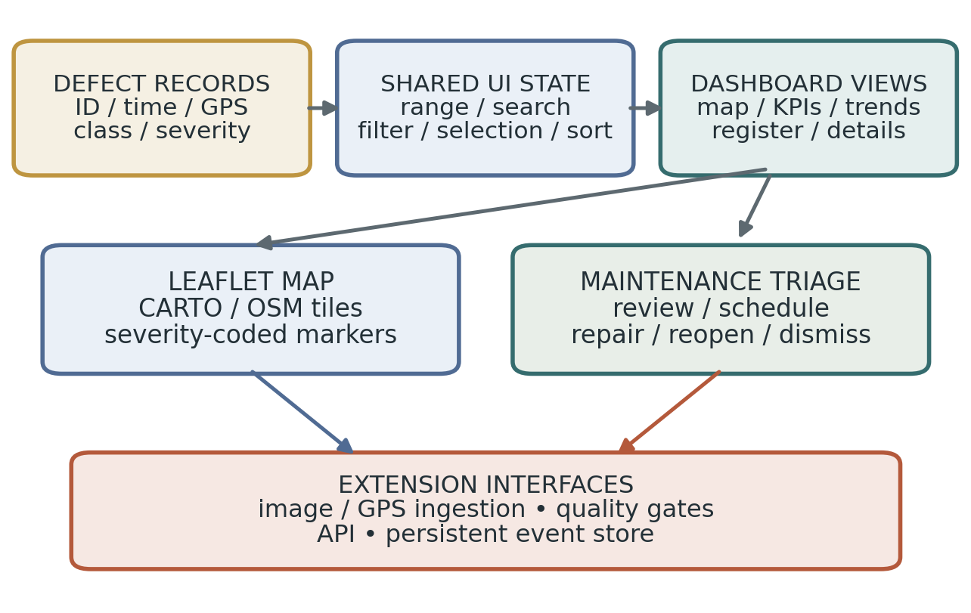
Fig. 1. Roadwatch architecture. The browser interface and map consume structured records; persistence and sensing services are modular integration boundaries.
The interface has five coordinated areas: (1) an attention banner for unresolved critical items; (2) KPI cards for attention, review, scheduled, repaired, and total records; (3) an interactive defect map; (4) severity and detection-volume summaries; and (5) a searchable register linked to a detail drawer. Shared state includes the time range, active filter, text query, selected record identifier, sort key, and sort direction. A common render path updates the relevant views after interaction.
The time-range selector supports rolling 24-hour, 7-day, and 30-day windows. Filters include all records, records needing attention, critical records, scheduled items, and repaired items. Search checks the road name, area, and record identifier. The register can sort by severity, confidence field, or detection time. Selecting a map marker or table row opens the same record in the detail drawer. Context-sensitive actions move records through scheduling, repair, reopening, dismissal, and restoration where applicable. The theme control and responsive breakpoints support desktop and narrow-screen use.
The current client-side architecture lowers the deployment barrier and is suitable for rapid iteration. For multi-user operation, a server-side API and persistent database should become authoritative for records and status history. The client should not be the authority for access control or audit records. A versioned event contract can preserve a stable interface while adding image ingestion, model versioning, GPS provenance, role-based permissions, and repair evidence.

V. EVENT MODEL AND OPERATIONAL WORKFLOW
The schema must retain enough context for operators and later analysis without coupling the registry to one detector. Data quality is treated as completeness, consistency, and fitness for use rather than coordinate syntax alone [13]. Table I summarizes the core attributes. A production event should additionally record coordinate reference system, horizontal accuracy, source device or reporter, evidence reference, detector name and version, validation state, timestamps for receipt and review, assigned crew, and state-transition history. Missing location or evidence should be marked explicitly rather than silently inferred.
TABLE I. ROAD-DEFECT EVENT SCHEMA AND VALIDATION
Field | Meaning | Validation rule
event_id, observed_at | Stable identity and capture time | Unique ID; ISO 8601 timestamp with explicit timezone.
latitude, longitude | WGS 84 geographic position | Range check, source accuracy, and road alignment.
damage_class, severity | Damage type and triage level | Controlled labels; retain reviewer and policy version.
confidence, model_version | Optional detector score and provenance | Score in [0,1] plus version; score is not accuracy.
status, crew, evidence_ref | Workflow and supporting evidence | Allowed status; access control; log every transition.

A proposed operational lifecycle contains seven stages: observe, detect or report, validate location and evidence, consolidate repeat observations, prioritize, dispatch, and verify closure. Fig. 2 illustrates the intended sequence. Raw events should remain available even when several observations are grouped as one maintenance candidate. This preserves the audit trail and allows reviewers to inspect why a particular group was formed.
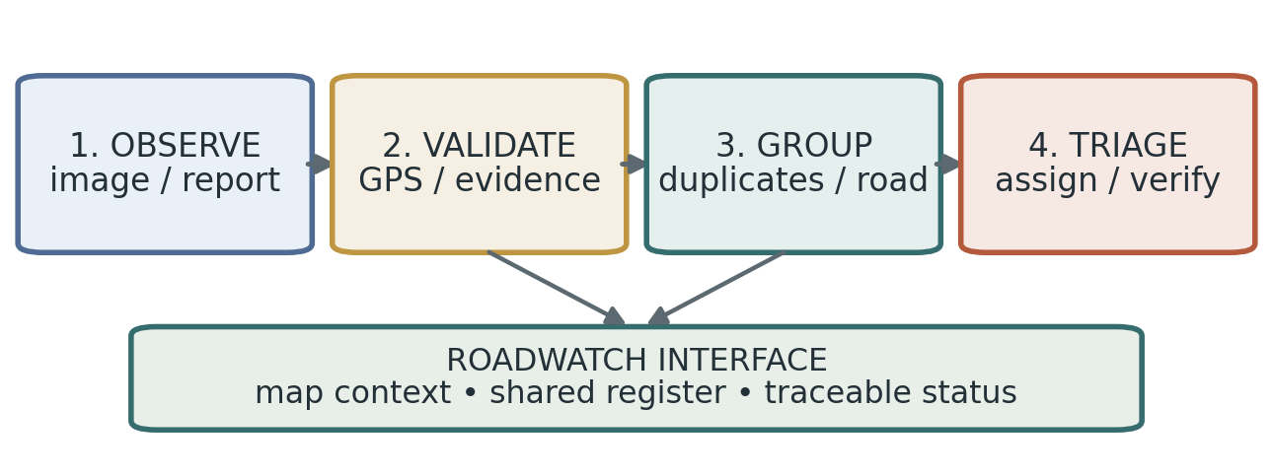
Fig. 2. Road-defect event lifecycle from observation through validation, consolidation, prioritization, dispatch, and verification.
For map validation, simple coordinate bounds can reject malformed values but cannot prove that a point lies on the named road. A stronger pipeline checks distance to a candidate road segment, carriageway plausibility, GPS accuracy, timestamp validity, and source quality. Events with uncertain positions can remain in a review queue until corrected. Status changes should be retained as timestamped events in a persistent deployment, with optimistic concurrency or version checks to prevent silent overwrites by multiple users.

VI. DATA-SCIENCE EXTENSION

A. Coordinate Quality and Duplicate Grouping
The geospatial layer should reject invalid latitude/longitude ranges, normalize coordinate reference systems, and calculate distance from an event to candidate road geometry. The Haversine distance between two coordinates (φ₁, λ₁) and (φ₂, λ₂) is d = 2R atan2(√a, √(1 − a)), where a = sin²(Δφ/2) + cos φ₁ cos φ₂ sin²(Δλ/2), angular differences are in radians, and R is the Earth mean radius. This is useful for candidate screening but should not replace road-network matching where the carriageway matters.
Duplicate candidates may be generated when two events share a compatible damage class, occur within a time window τₜ, and are separated by less than a distance threshold τd. When available, the same road-segment ID and travel direction provide stronger evidence than distance alone. Thresholds must be calibrated from reviewed positive and negative pairs. The system should preserve raw event identifiers and represent consolidation as a reversible relationship, so distinct nearby defects are not irreversibly collapsed.

B. Road-Segment Hotspots
For segment s with length Lₛ kilometres and nₛ validated observations in a defined period, a simple observed-record rate is rₛ = nₛ / Lₛ. Where exposure information exists, counts can also be normalized by inspection trips, traffic volume, or another approved denominator. Getis–Ord local statistics and local indicators of spatial association can be evaluated for hotspot detection [7], [8], but results depend on spatial weights, neighborhood definition, and the null model. Until exposure and statistical assumptions are validated, the dashboard should label outputs as observed-record concentrations rather than definitive measures of underlying road risk.

C. Explainable Maintenance Priority
A transparent triage score can combine normalized severity Sᵢ, exposure Eᵢ, recurrence Rᵢ, and waiting age Aᵢ: Pᵢ = wₛSᵢ + wₑEᵢ + wᵣRᵢ + wₐAᵢ, where every component is scaled to [0,1], weights are non-negative, and wₛ + wₑ + wᵣ + wₐ = 1. The score is a policy-controlled decision aid, not an autonomous dispatch decision. Evidence quality and detector confidence should remain separately visible: a low-quality observation can trigger verification without automatically raising or lowering the physical severity estimate.
The score should be calibrated with municipal staff and evaluated through sensitivity analysis. If rankings change substantially under small weight changes, the dashboard should expose that instability rather than present a false sense of precision. A human supervisor must be able to override a priority with a reason, and the system should record the score version and component values that informed the decision.

VII. FUNCTIONAL EVALUATION AND REGISTRY RESULTS
Functional evaluation covers the user-facing application paths and descriptive summaries of the current 30-record registry. The tested browser workflow exercises map initialization and marker display, popup-to-drawer identity, table-row selection, search, time-range controls, filter chips, sorting, summary updates, record actions, theme change, responsive layout, and visible map attribution. Table II records the expected checks and outcome. These checks validate interface behavior under the project test conditions; they do not substitute for benchmark testing of an image detector or a field study of maintenance performance.
TABLE II. FUNCTIONAL VALIDATION CHECKS
ID | Test scenario | Outcome
F1 | Load map, markers, and basemap attribution | Pass
F2 | Open the same record from map and table | Pass
F3 | Search by record ID, road, or area | Pass
F4 | Apply time range and update scoped views | Pass
F5 | Apply severity/status filters | Pass
F6 | Sort the register and refresh summaries | Pass
F7 | Use status actions and detail drawer | Pass
F8 | Switch theme and resize responsive layout | Pass

In the current registry, the severity distribution is 5 minor, 11 moderate, 8 severe, and 6 critical records. The workflow states comprise 5 new, 4 in review, 7 scheduled, 12 repaired, and 2 dismissed records. The mean of the 30 stored confidence fields is 0.839. The rolling seven-day view contains 20 records and the 24-hour view contains 5 records under the application’s current timestamp logic. These figures show how the application aggregates and filters a registry; they do not estimate citywide defect prevalence or independently measured detection correctness.
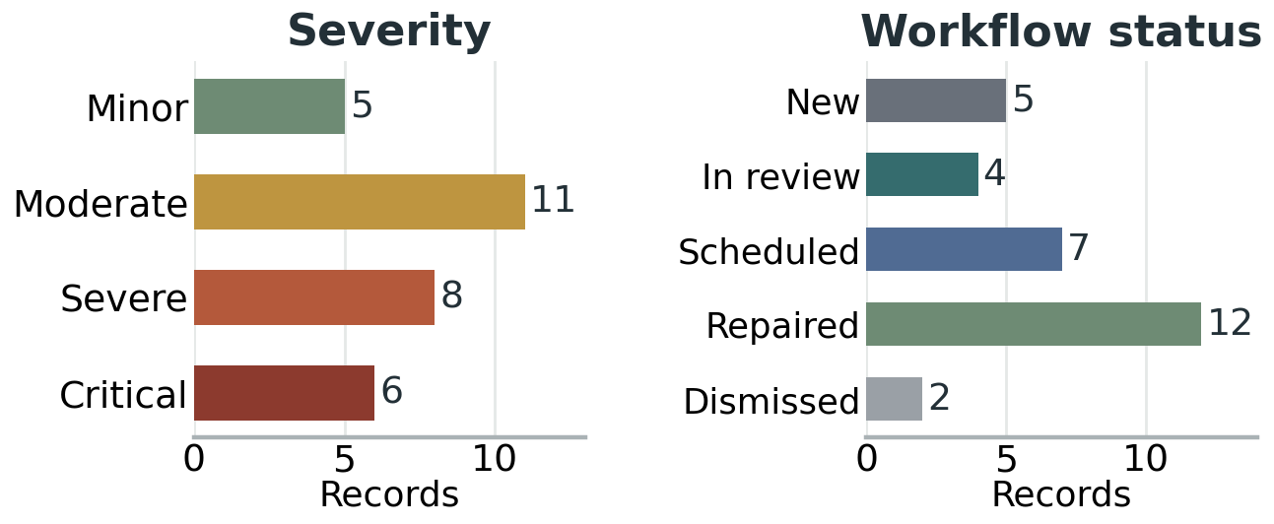
Fig. 3. Composition of the 30 records in the current Roadwatch registry by severity and workflow status.
Confidence requires careful interpretation. The arithmetic mean of stored confidence values is not equivalent to model accuracy, calibrated probability, precision, or recall. A rigorous detector benchmark requires annotated imagery and a held-out test split, with class-wise precision, recall, F1-score, intersection over union (IoU), mean average precision (mAP), inference latency, and error analysis. Geographic performance should be evaluated separately using median and percentile distance from the recorded point to verified road position. Duplicate grouping should be evaluated on reviewed event pairs, and maintenance impact should be measured using pre-defined response-time and closure outcomes.

VIII. SMART-CITY RELEVANCE, GOVERNANCE, AND DISCUSSION
Roadwatch supports the information-management layer of urban road maintenance by making observations easier to locate, compare, review, and route. This aligns with smart-city goals around reliable infrastructure and with Sustainable Development Goal 11 on inclusive, safe, resilient, and sustainable cities [12], [14]. Expected operational benefits include a common view of reported defects, explicit attention to unresolved high-severity items, quicker discovery of records, and a consistent workflow vocabulary. These are design objectives; their magnitude should be measured in a municipal pilot rather than assumed from interface availability.
Data governance is part of the technical design. Road imagery may contain faces, license plates, home entrances, or other identifying details. A deployment should define collection purpose, role-based access, redaction where necessary, retention limits, secure evidence storage, and rules for public release. The basemap API key should be restricted to approved origins and monitored for usage, and map attribution should remain visible in accordance with provider requirements [10], [11]. The client should not contain credentials that grant privileged access to backend data.
The main limitations are scope and evidence. The present application is a client-side dashboard; a production service requires persistent storage, authentication, audit logging, and concurrency control. Configured coordinates require source and accuracy metadata before they are used for engineering decisions. Spatial clustering and priority ranking need local calibration, suitable exposure denominators, and review by road engineers. A phased next step is to connect a versioned ingestion API and persistent event store, then evaluate image detection and location quality on local held-out data, followed by a small workflow pilot with a measured baseline.

A. Threats to Validity
Several validity boundaries should be kept explicit. Functional checks establish that the tested browser workflow behaves as expected under the recorded setup, but they do not quantify usability across every operator group or browser. The registry summaries describe the records currently loaded by the application and cannot be generalized to Chennai as a whole without a known sampling frame and exposure denominator. Spatial hot spots can reflect inspection intensity rather than underlying defect prevalence, and priority-score rankings depend on locally approved weights. Detector metrics require a held-out annotated dataset, while repair and safety benefits require a measured baseline and follow-up observations. These limitations are addressed by separating the evidence types, retaining provenance, and defining a staged evaluation plan before connected deployment.

IX. CONCLUSION
This paper presented Roadwatch, a geospatial decision-support dashboard for municipal road-defect monitoring and maintenance triage. The implementation combines Leaflet-based mapping, severity-coded markers, summary indicators, time-window controls, search, filters, sorting, record details, and status actions in a responsive browser interface. A shared client-side state aligns map, table, and summary views around stable event identifiers. The accompanying data model and lifecycle specify how observations can be made traceable from validation through repair verification.
The paper also defines a data-science extension for coordinate quality checks, spatiotemporal duplicate grouping, road-segment hotspot analysis, and transparent priority ranking. Its evaluation framework separates interface function from perception metrics, geospatial accuracy, and operational outcomes. The current registry supports descriptive dashboard checks, while an independent detector benchmark and a municipal field study remain distinct evaluation tasks. This separation makes Roadwatch a practical, extensible foundation for data-informed road maintenance in smart-city operations.

ACKNOWLEDGMENT
The authors thank [Faculty Guide Name] and the project reviewers for their guidance. Add any institutional, funding, data, or infrastructure support before submission.

AUTHOR CONTRIBUTIONS
Author 1: [contribution]. Author 2: [contribution]. Author 3: [contribution]. Corresponding faculty author: [contribution]. Final statements must be confirmed by all authors.

REFERENCES
[1] H. Maeda, Y. Sekimoto, T. Seto, T. Kashiyama, and H. Omata, “Road damage detection and classification using deep neural networks with smartphone images,” Computer-Aided Civil and Infrastructure Engineering, vol. 33, no. 12, pp. 1127–1141, 2018, doi: 10.1111/mice.12387.
[2] D. Arya, H. Maeda, S. K. Ghosh, D. Toshniwal, and Y. Sekimoto, “RDD2022: A multi-national image dataset for automatic road damage detection,” Geoscience Data Journal, vol. 11, no. 4, pp. 846–862, 2024, doi: 10.1002/gdj3.260.
[3] S. H. Abdelwahed, B. K. Sharobim, B. Wasfey, et al., “Advancements in real-time road damage detection: a comprehensive survey of methodologies and datasets,” Journal of Real-Time Image Processing, vol. 22, Art. no. 137, 2025, doi: 10.1007/s11554-025-01683-1.
[4] G. Singh, D. Bansal, S. Sofat, and N. Aggarwal, “Smart patrolling: An efficient road surface monitoring using smartphone sensors and crowdsourcing,” Pervasive and Mobile Computing, vol. 40, pp. 71–88, 2017, doi: 10.1016/j.pmcj.2017.06.002.
[5] S. Ren, K. He, R. Girshick, and J. Sun, “Faster R-CNN: Towards real-time object detection with region proposal networks,” in Advances in Neural Information Processing Systems, vol. 28, 2015.
[6] J. Redmon, S. Divvala, R. Girshick, and A. Farhadi, “You Only Look Once: Unified, real-time object detection,” in Proc. IEEE Conf. Computer Vision and Pattern Recognition (CVPR), 2016, pp. 779–788, doi: 10.1109/CVPR.2016.91.
[7] A. Getis and J. K. Ord, “The analysis of spatial association by use of distance statistics,” Geographical Analysis, vol. 24, no. 3, pp. 189–206, 1992, doi: 10.1111/j.1538-4632.1992.tb00261.x.
[8] L. Anselin, “Local indicators of spatial association—LISA,” Geographical Analysis, vol. 27, no. 2, pp. 93–115, 1995, doi: 10.1111/j.1538-4632.1995.tb00338.x.
[9] V. Agafonkin and Leaflet contributors, “Leaflet Quick Start Guide,” Leaflet documentation. [Online]. Available: https://leafletjs.com/examples/quick-start/ (accessed Oct. 11, 2026).
[10] CARTO, “Get your CARTO Basemaps API key.” [Online]. Available: https://carto.com/basemaps/apikey/ (accessed Oct. 11, 2026).
[11] OpenStreetMap Foundation, “Tile usage policy.” [Online]. Available: https://operations.osmfoundation.org/policies/tiles/ (accessed Oct. 11, 2026).
[12] United Nations Department of Economic and Social Affairs, “Goal 11: Make cities and human settlements inclusive, safe, resilient and sustainable.” [Online]. Available: https://sdgs.un.org/goals/goal11 (accessed Oct. 11, 2026).
[13] R. Y. Wang and D. M. Strong, “Beyond accuracy: What data quality means to data consumers,” Journal of Management Information Systems, vol. 12, no. 4, pp. 5–33, 1996, doi: 10.1080/07421222.1996.11518099.
[14] Ministry of Housing and Urban Affairs, Government of India, “Implementation of Smart Cities Mission,” Press Information Bureau, Dec. 11, 2023. [Online]. Available: https://www.pib.gov.in/Pressreleaseshare.aspx?PRID=1984980.

